NPC UNIT 4 ASSIGNMENT REPORT
Configure DHCP and Set Up a Network Using Cisco Packet Tracer
Name: Sakshi Jarhad
PRN: 2125UCSF1103
Subject: Network Protocol Configuration (NPC)
1. Aim
To configure a DHCP server and set up a small network using Cisco Packet Tracer. The main aim is to assign IP addresses automatically to PCs and test network connectivity.
2. Software and Hardware Requirements
- Cisco Packet Tracer software
- One 2960 Switch
- One Server
- Two PCs (PC0 and PC1)
- Copper Straight-Through cables
3. Network Topology
In this practical, I created a simple network using one switch, one server, and two PCs. PC0, PC1, and Server0 were connected to the switch using Copper Straight-Through cables.
The switch connects all the devices and allows them to communicate with each other within the local network.
Screenshot 1: Network topology
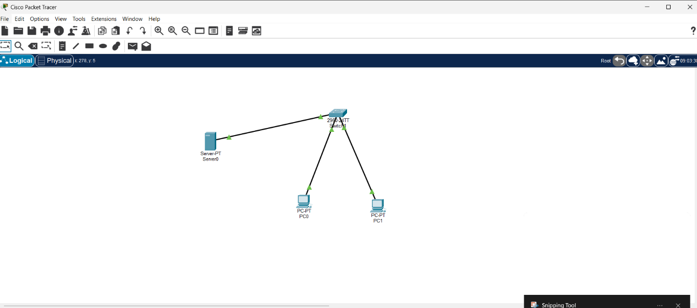
4. Server IP Configuration
I configured a static IP address on Server0 to provide DHCP services to the PCs.
The server settings were:
- IP Address: 192.168.1.2
- Subnet Mask: 255.255.255.0
- Default Gateway: 192.168.1.1
- DNS Server: 192.168.1.2
Screenshot 2: Server ip conifiguration
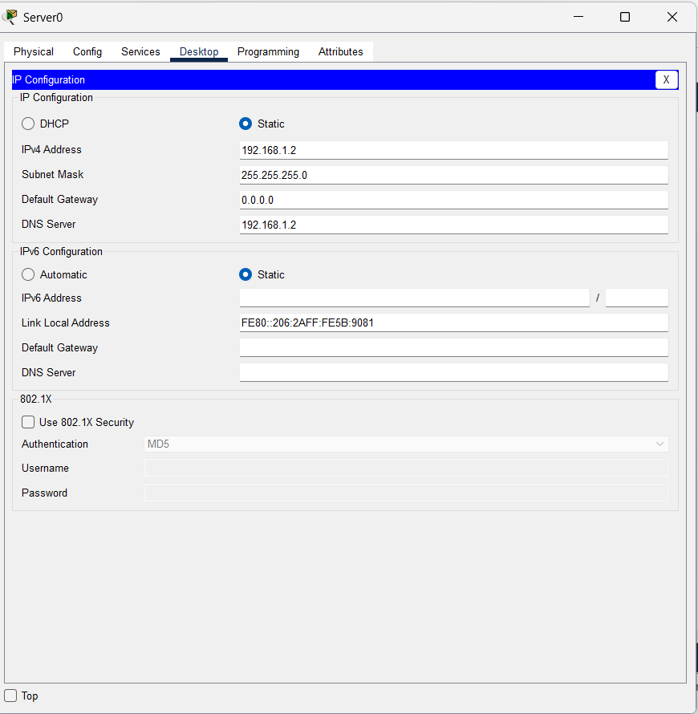
5. DHCP Server Configuration
I opened Server0 and selected the Services tab. Then I selected DHCP and turned the DHCP service ON.
I created a DHCP pool named LAN_POOL and configured the following settings:
- Pool Name: LAN_POOL
- Default Gateway: 192.168.1.1
- DNS Server: 192.168.1.2
- Start IP Address: 192.168.1.10
- Subnet Mask: 255.255.255.0
- Maximum Number of Users: 50
After entering the details, I added the pool to the DHCP server.
Screenshot 3: DHCP Service Configuration
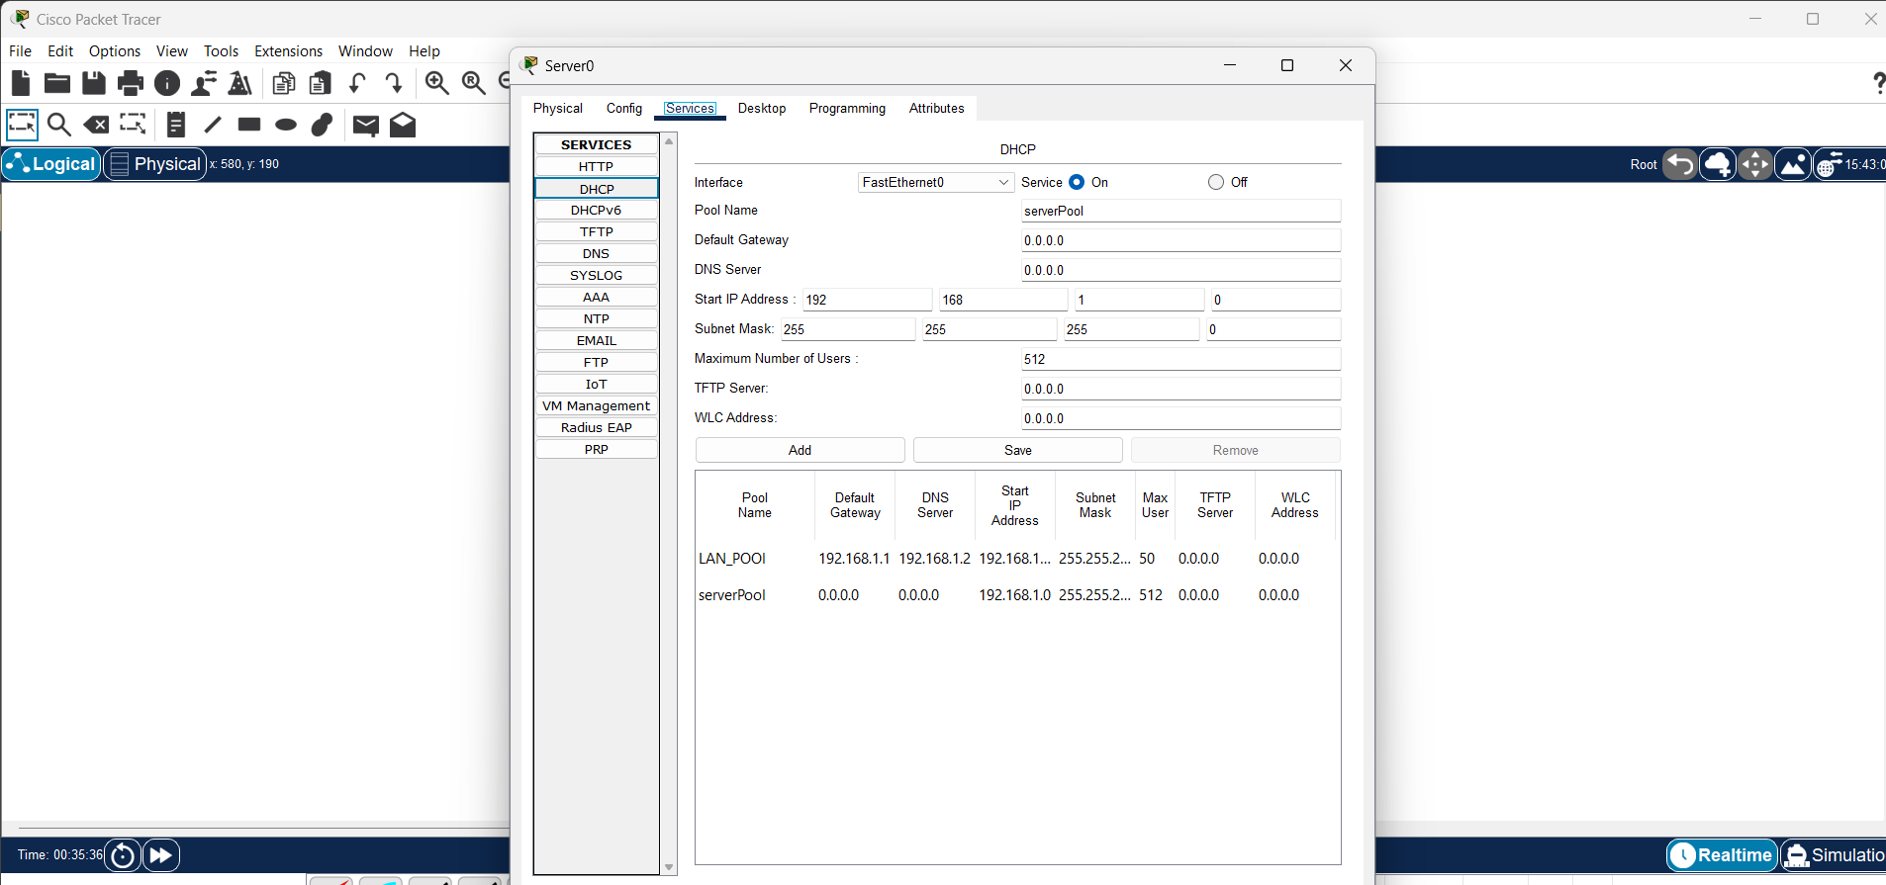
6. PC IP Configuration
I opened the Desktop tab on PC0 and PC1 and selected IP Configuration. Then I selected DHCP to obtain IP addresses automatically.
Both PCs were configured to request their IP addresses from the DHCP server.
Screenshot 4: PC0 IP Conifiguration
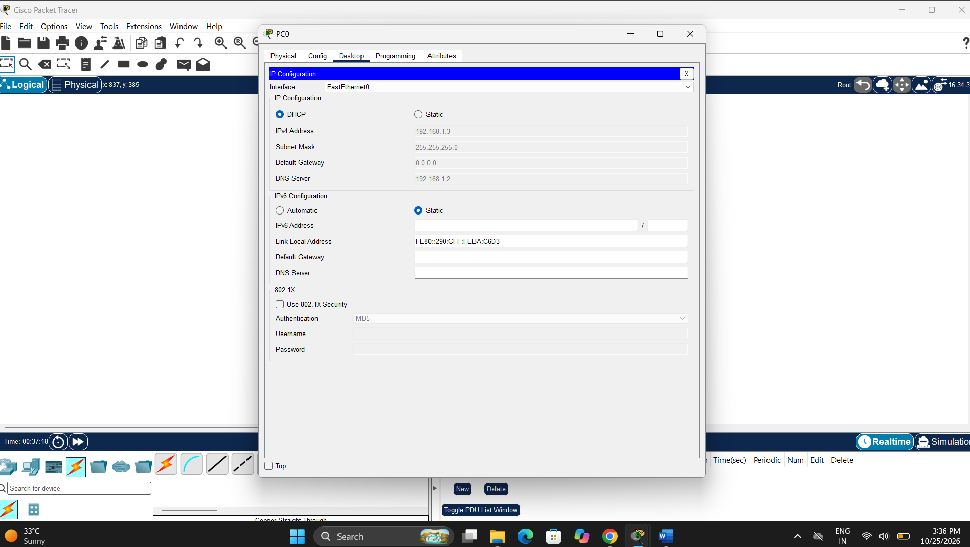
Screenshot 5: PC1 IP Configuration
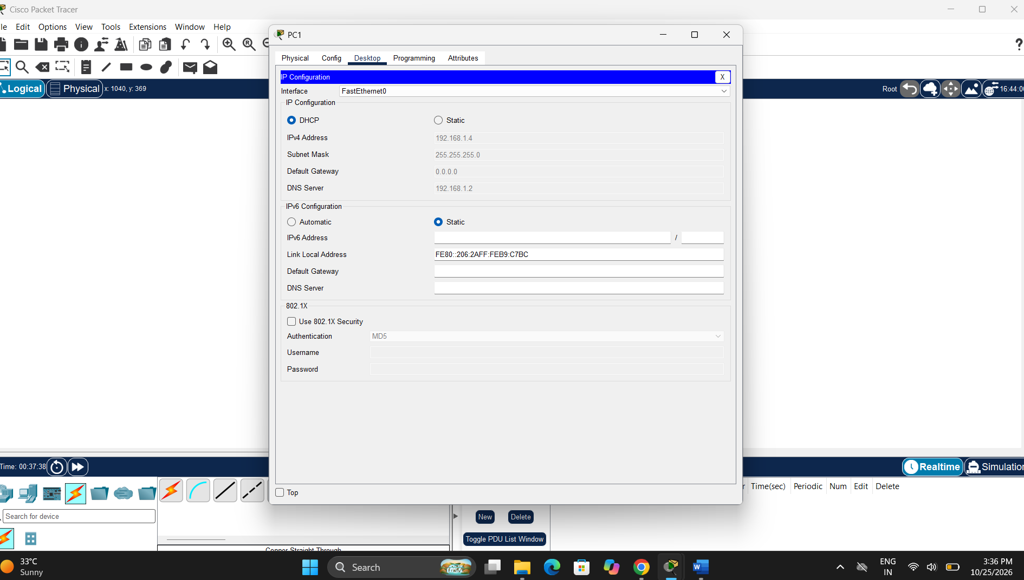
7. Connectivity Testing
To check network connectivity, I opened the Command Prompt on PC0 and used the ping command to test communication with PC1.
Command used:
ping 192.168.1.11
The command returned successful replies after I configured the IP addresses for the connectivity test. This confirmed that PC0 and PC1 could communicate with each other using those settings.
Screenshot 6: 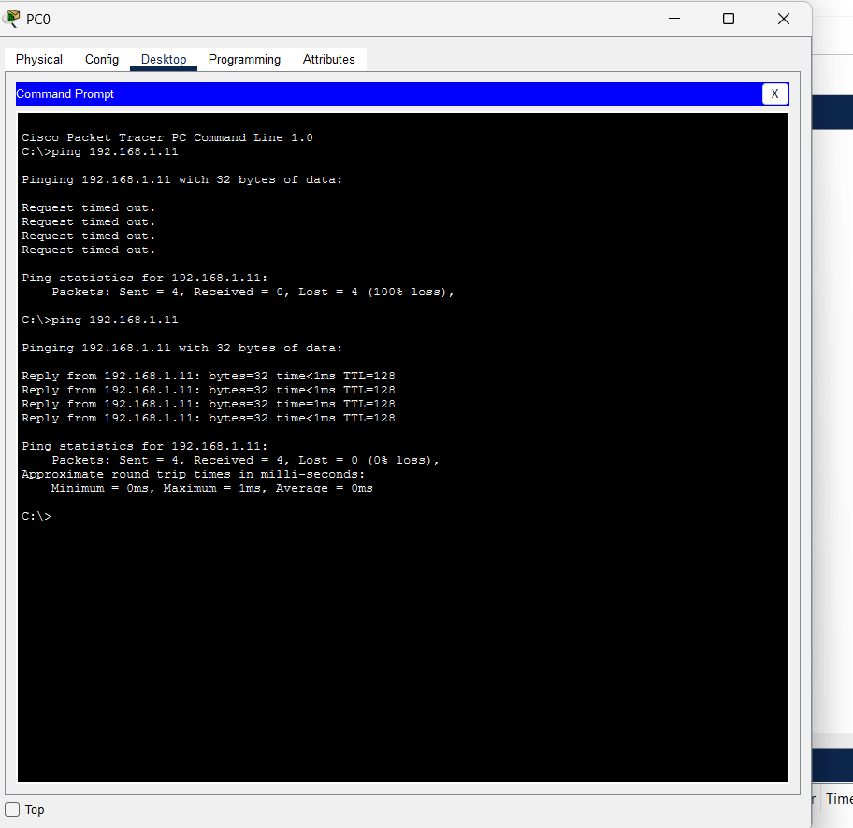
8. Result
The network was created successfully in Cisco Packet Tracer. The DHCP service and LAN_POOL were configured, and the PCs were able to obtain an IP address using DHCP. A successful ping test confirmed connectivity between the two PCs after IP configuration.
9. Conclusion
Through this practical, I learned how to create a simple network in Cisco Packet Tracer, configure a DHCP server, assign IP addresses to PCs, and test network connectivity using the ping command.

